WEBLEM: 1a
National Center for Biotechnology Information (NCBI)
(URL: https://www.ncbi.nlm.nih.gov/ )

Aim:
To gather information for the query “Diabetes” using various NCBI Resources

Introduction:
The National Center for Biotechnology Information (NCBI) was created in 1988 as a division of the National Library of Medicine (NLM) at the National Institutes of Health, to develop information systems in the field of molecular biology and bioinformatics. In addition to maintaining the GenBank, NCBI also provides data analysis and retrieval and resources that operate on GenBank data and also on a variety of other biological data made available through NCBI.
The query used today is Diabetes. Diabetes is a disorder affecting 422 million people
worldwide. Most commonly observed in obese individuals above the age of 40, diabetes is directly attributed with causing about 1.6 millions deaths each year. Learning more of how this disorder works on a molecular and genomix level will help us cushion the further blow of this disease.

Methodology / Procedure:
- Open Homepage of NCBI (url: https://www.ncbi.nlm.nih.gov/ )
- Enter search Query of Diabetes in various resources of NCBI (Total 5)
- Interpret the results and find the data needed.

Observations:
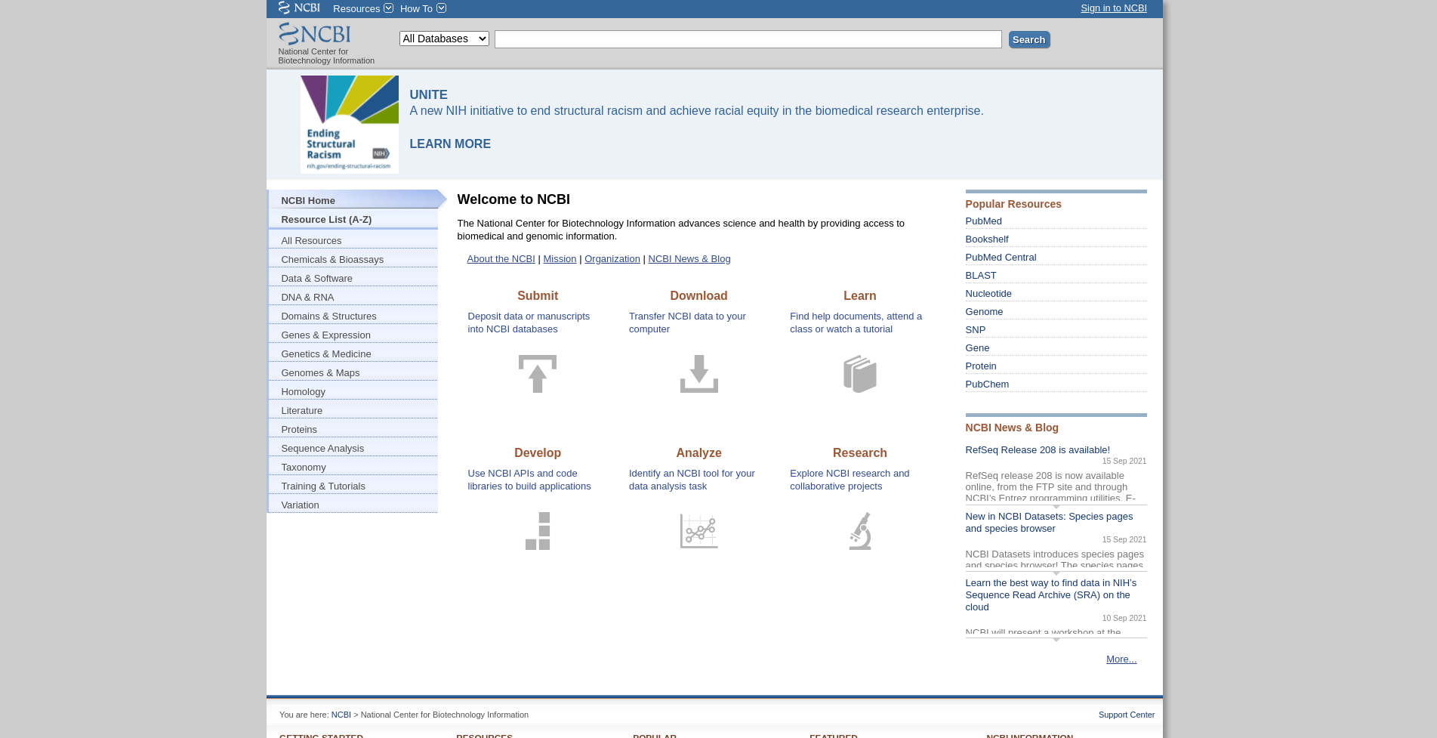
Fig1. NCBI Homepage
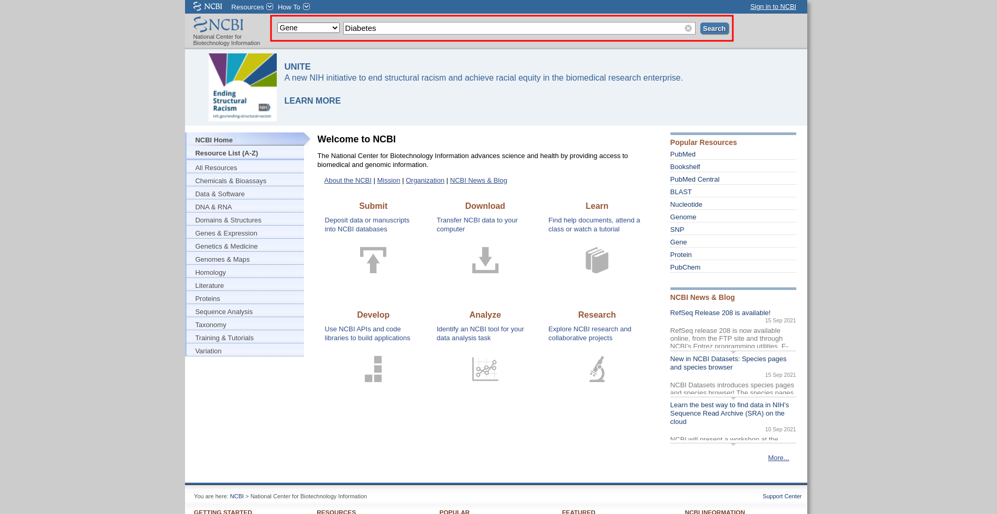
Fig2. Search page with resource Gene selected for query “Diabetes”

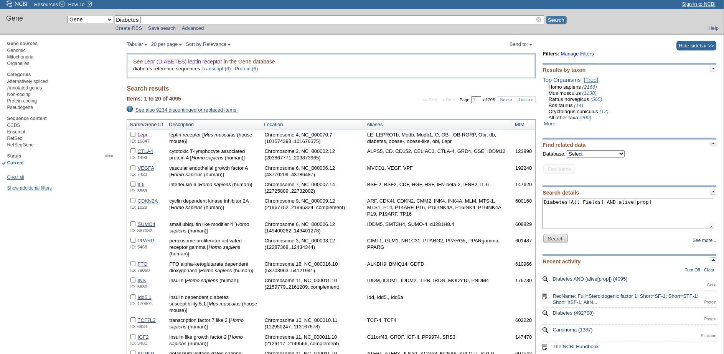
Fig3. Hit page for search query “Diabetes” in the Gene resource

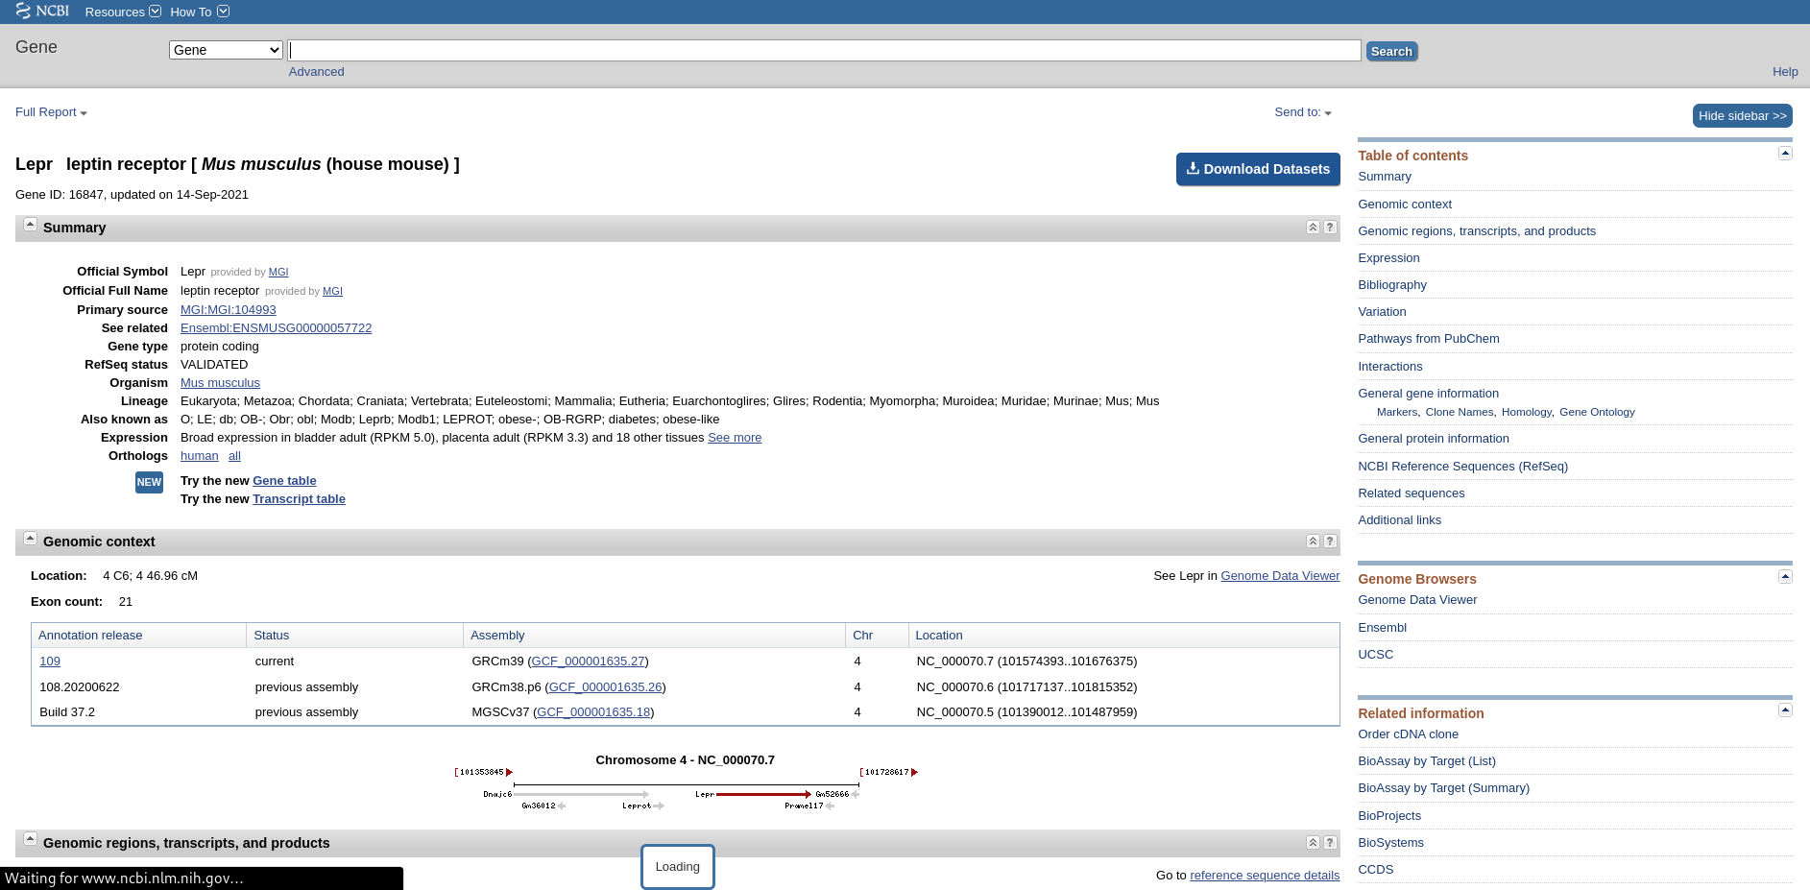
Fig4. Result page for gene resource on “Diabetes” [Lepr : leptin receptor in Mus musculus(house mouse)]

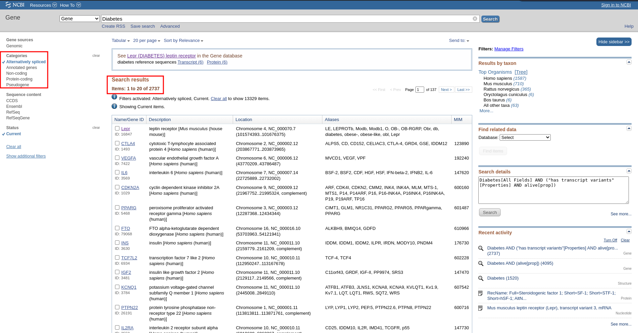
Fig5. Hit page for query “Diabetes” in gene resource with limit option and refined results.

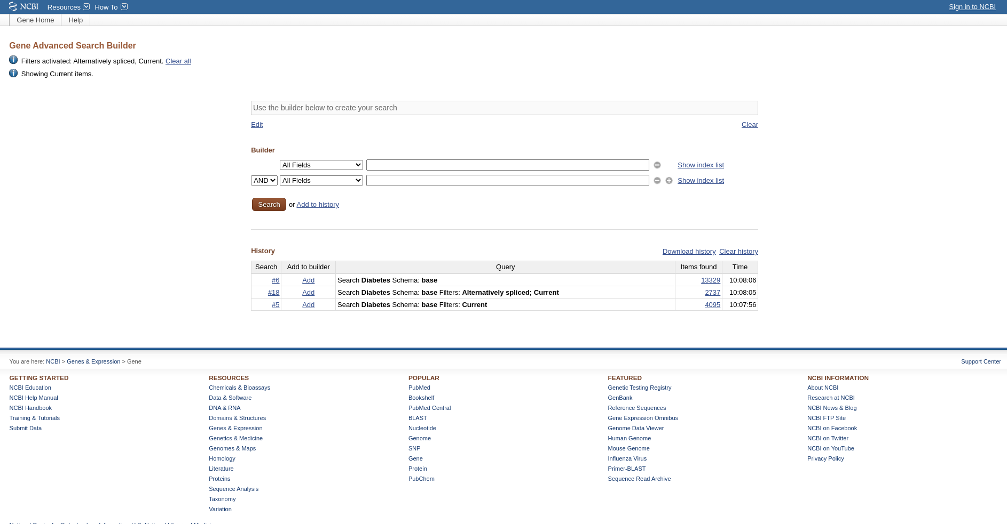
Fig6. Advanced search of query “Diabetes” in Gene Resource

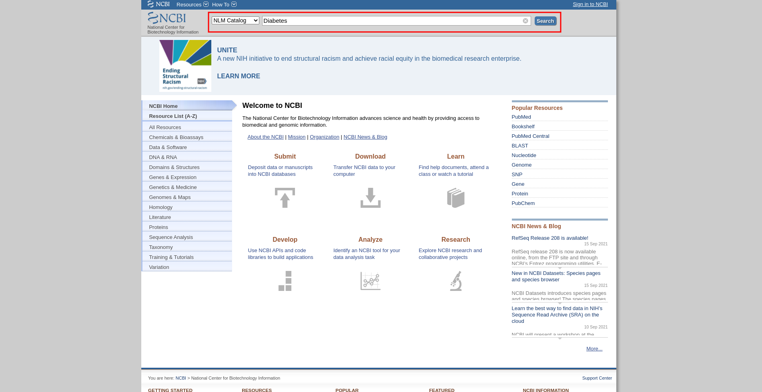
Fig7. Search page with resource NLM Catalog selected with query “Diabetes”
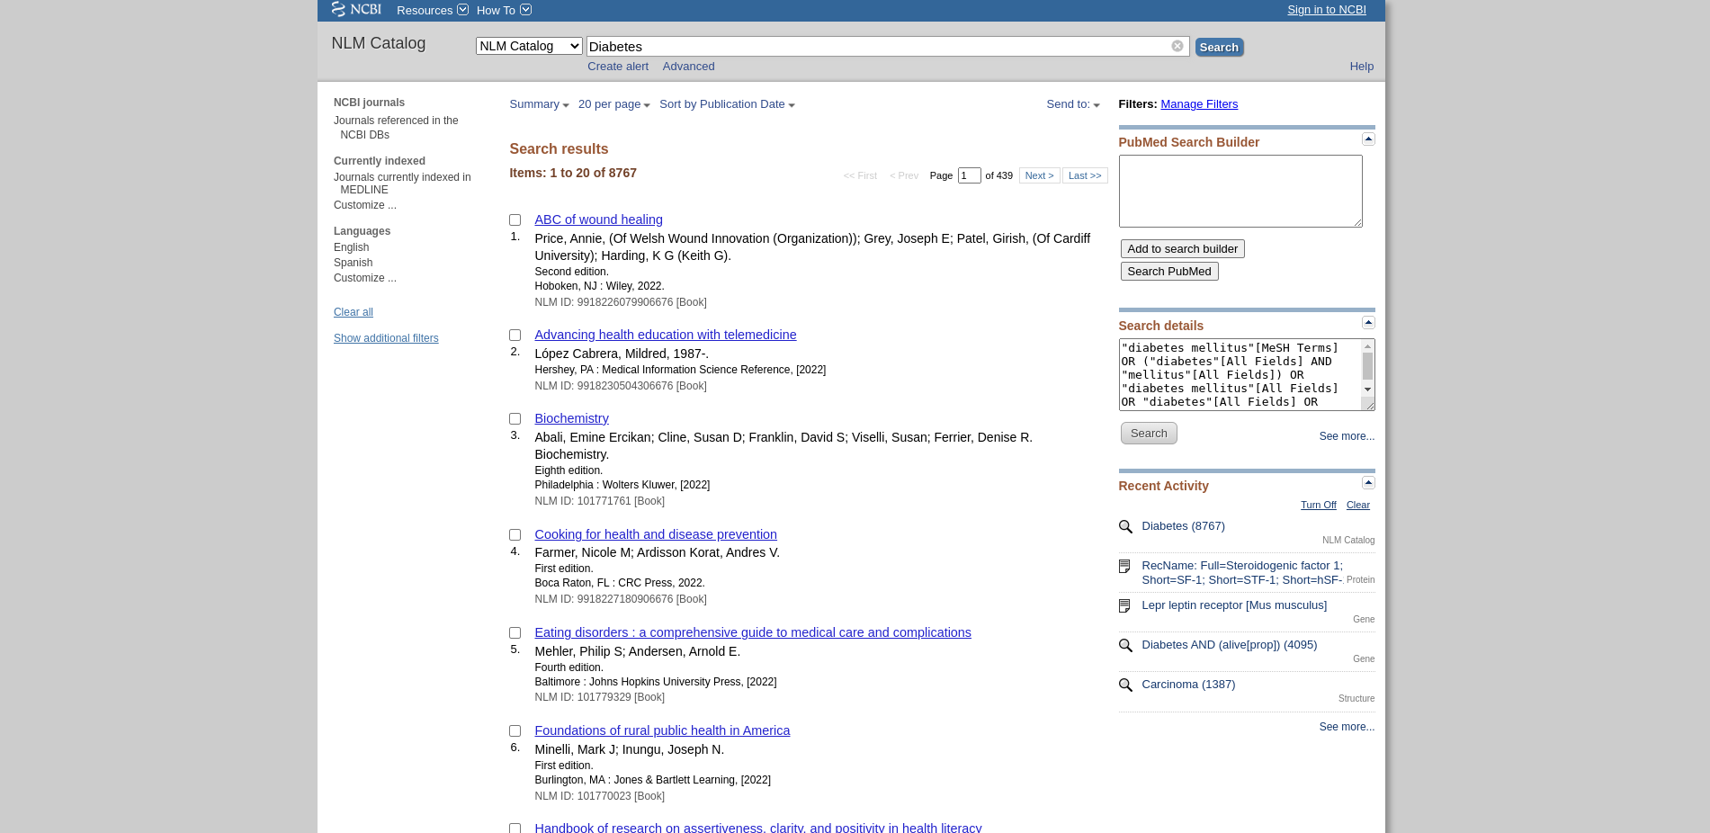
Fig8. Hit page for search query “Diabetes” in NLM catalog resource

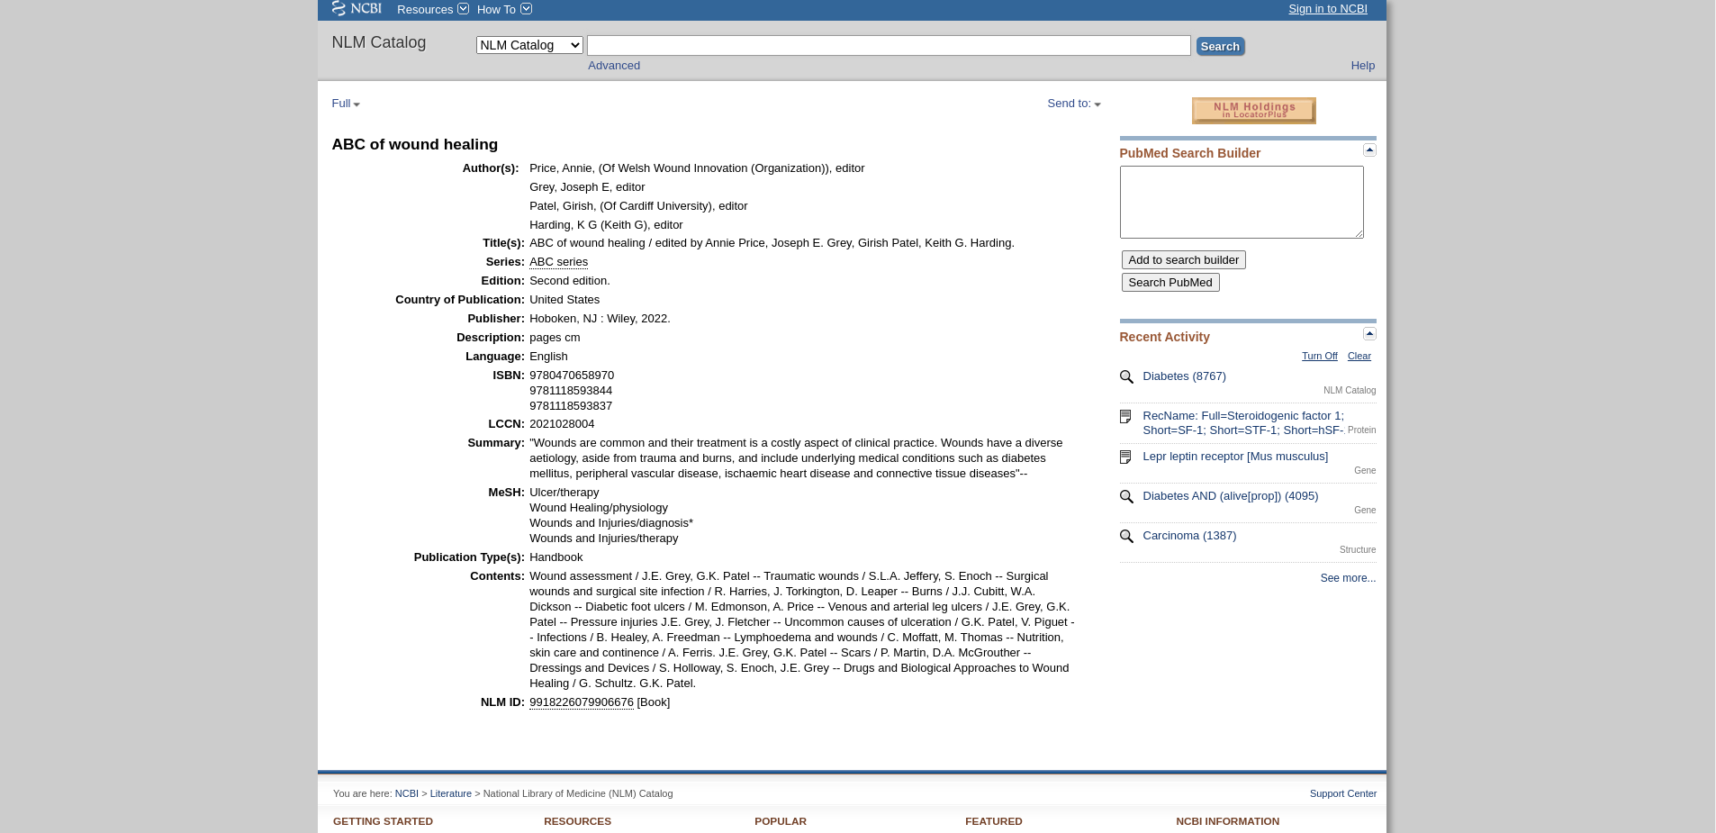
Fig9. Result Page for NLM catalog resource on “Diabetes” [ABC of wound healing]

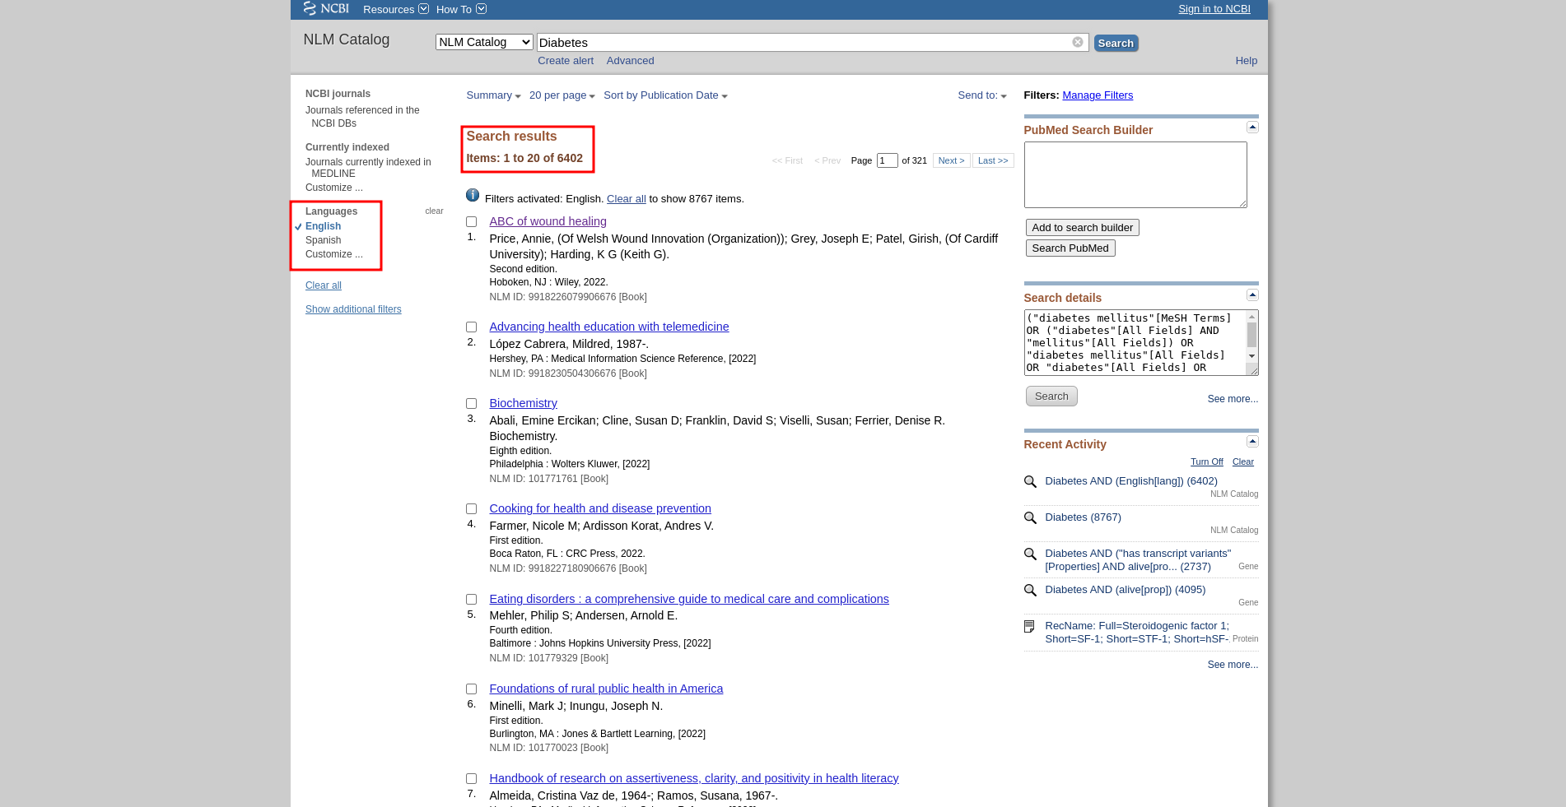
Fig10. Hit page for search query “Diabetes” in resource NLM catalog with Limit option and refined results

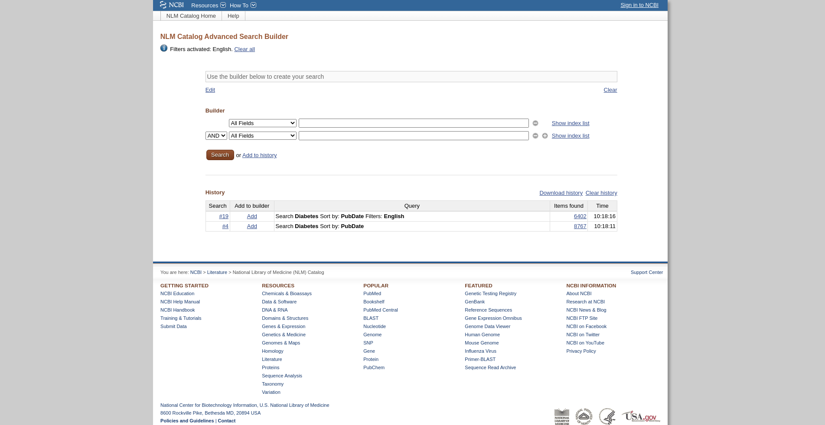
Fig11. Advanced search of Query “Diabetes” in NLM Catalog resource.

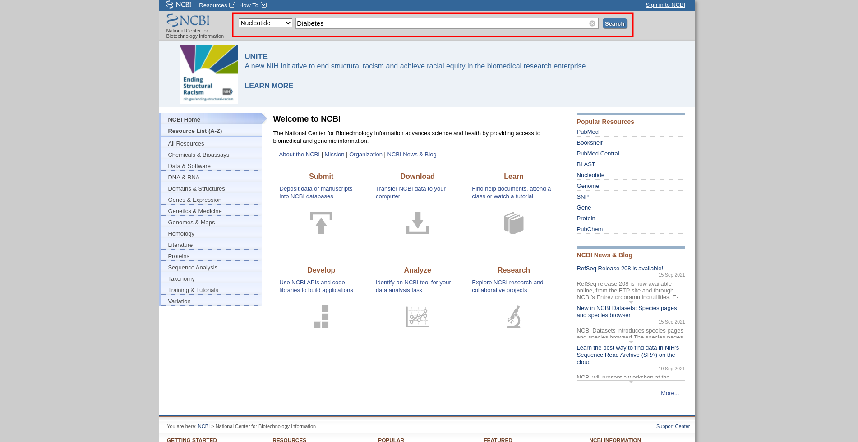
Fig12. Search page with resource Nucleotide selected with query “Diabetes”

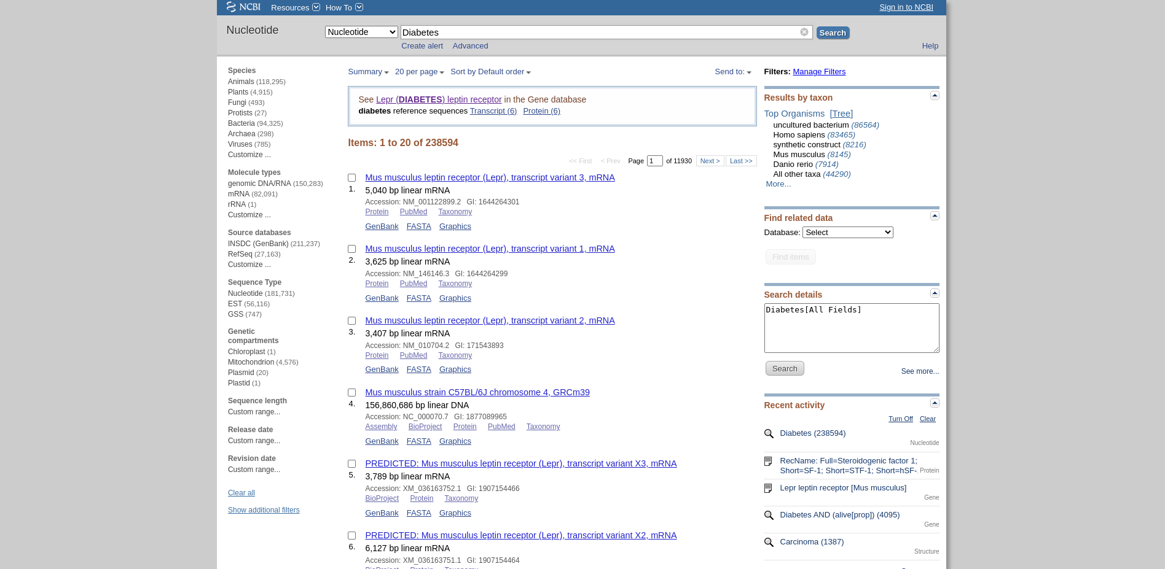
Fig13. Hit page for search query “Diabetes” in Nucleotide resource

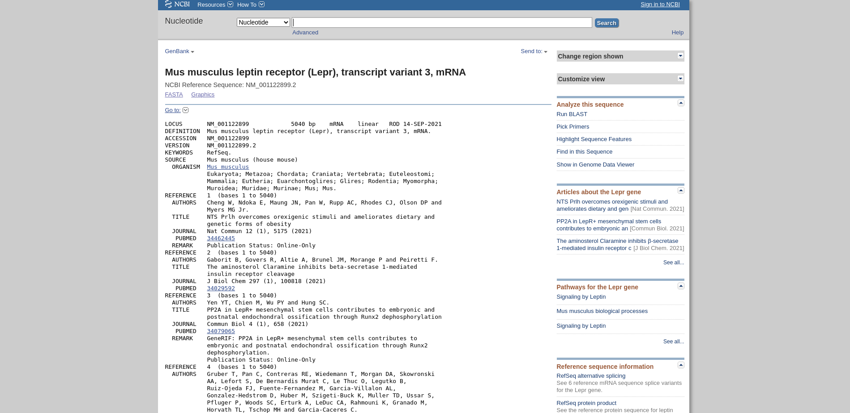
Fig14. Result Page for Nucleotide resource on “Diabetes” [Mus musculus leptin receptor (Lepr), transcript variant 3, mRNA]

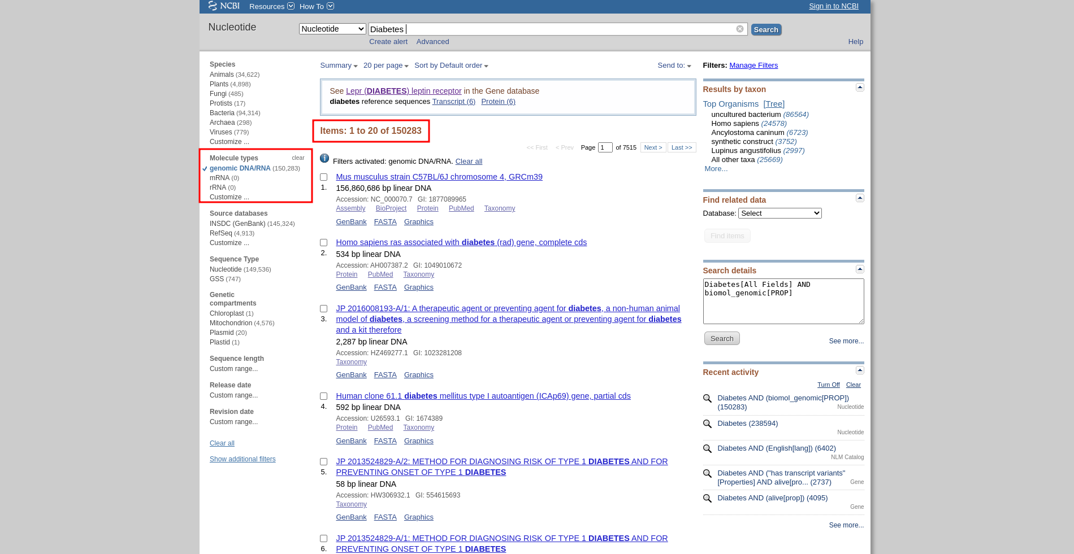
Fig15. Hit page for search query “Diabetes” in resource Nucleotide with Limit option and refined results

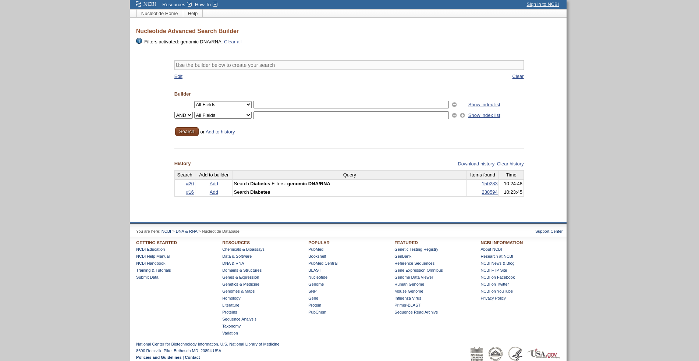
Fig16. Advanced search of Query “Diabetes” in Nucleotide resource.

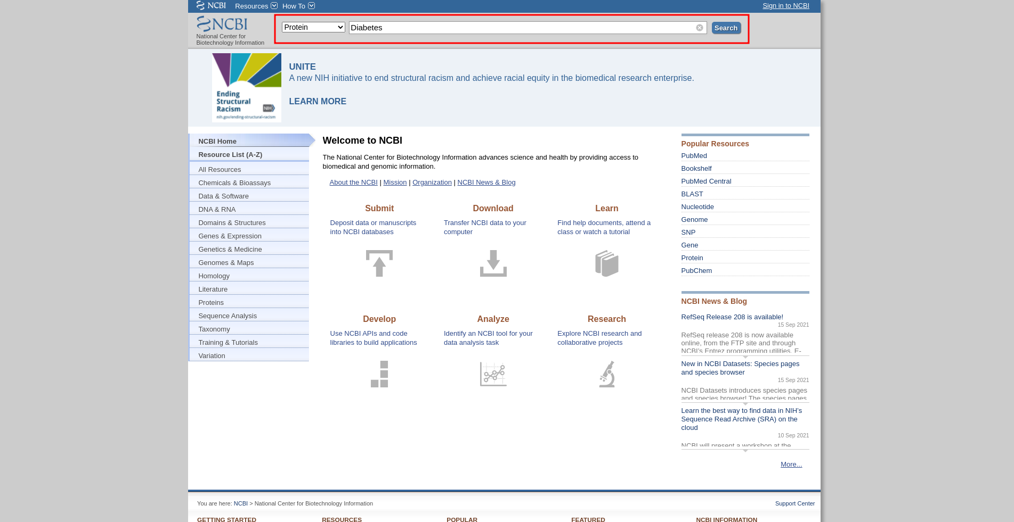
Fig17. Search page with resource Protein selected with query “Diabetes”

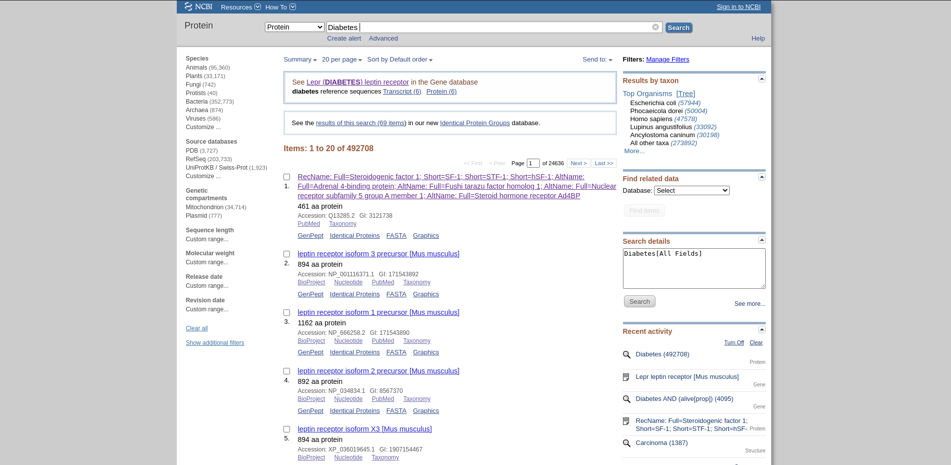
Fig18. Hit page for search query “Diabetes” in Protein resource

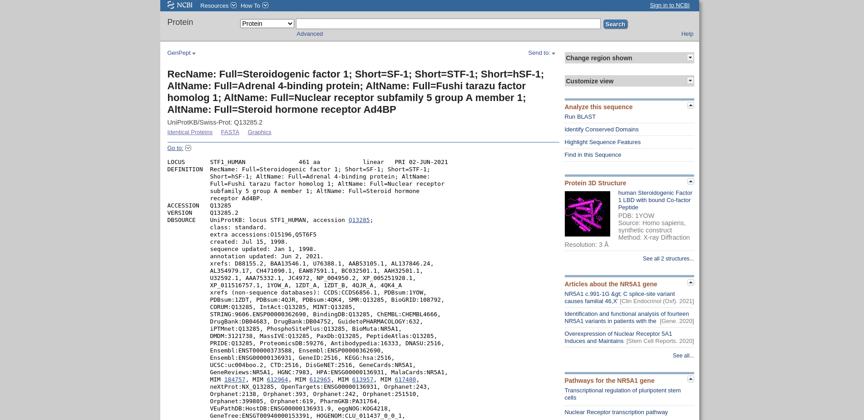
Fig19. Result Page for Protein resource on “Diabetes” [RecName: Full=Steroidogenic factor 1; Short=SF-1; Short=STF-1; Short=hSF-1; AltName: Full=Adrenal 4-binding protein; AltName: Full=Fushi tarazu factor homolog 1; AltName: Full=Nuclear receptor subfamily 5 group A member 1; AltName: Full=Steroid hormone receptor Ad4BP]

Fig20. Hit page for search query “Diabetes” in resource Protein with Limit option and refined results

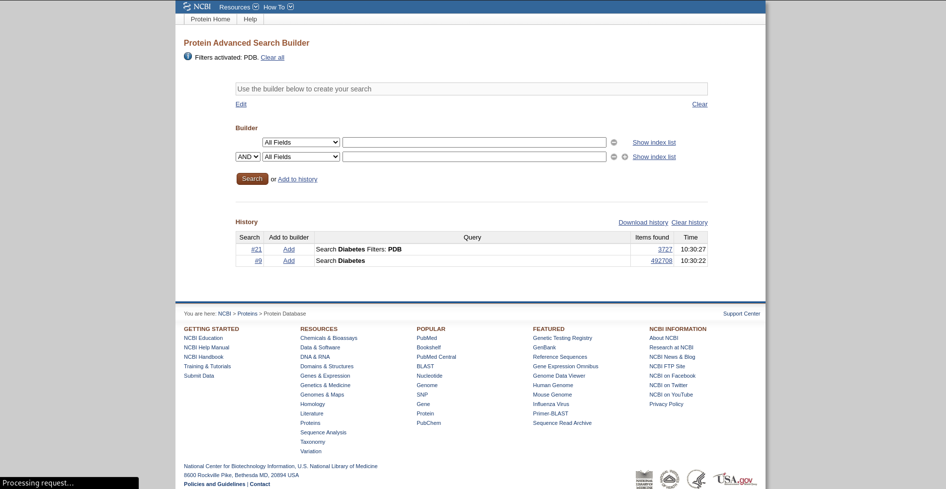
Fig21. Advanced search of Query “Diabetes” in Protein resource.

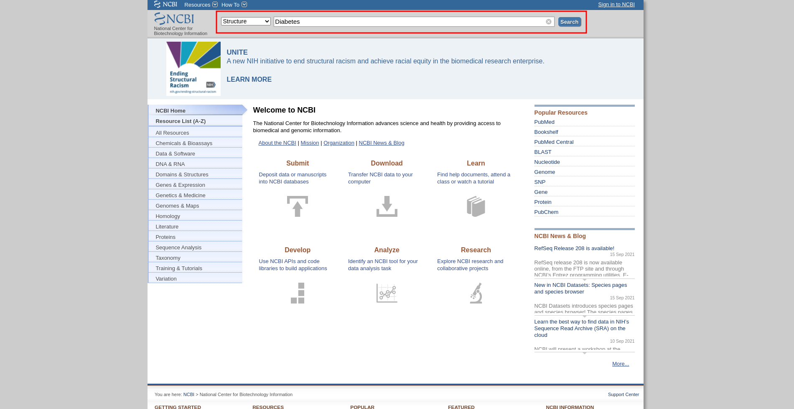
Fig22. Search page with resource Structure selected with query “Diabetes”

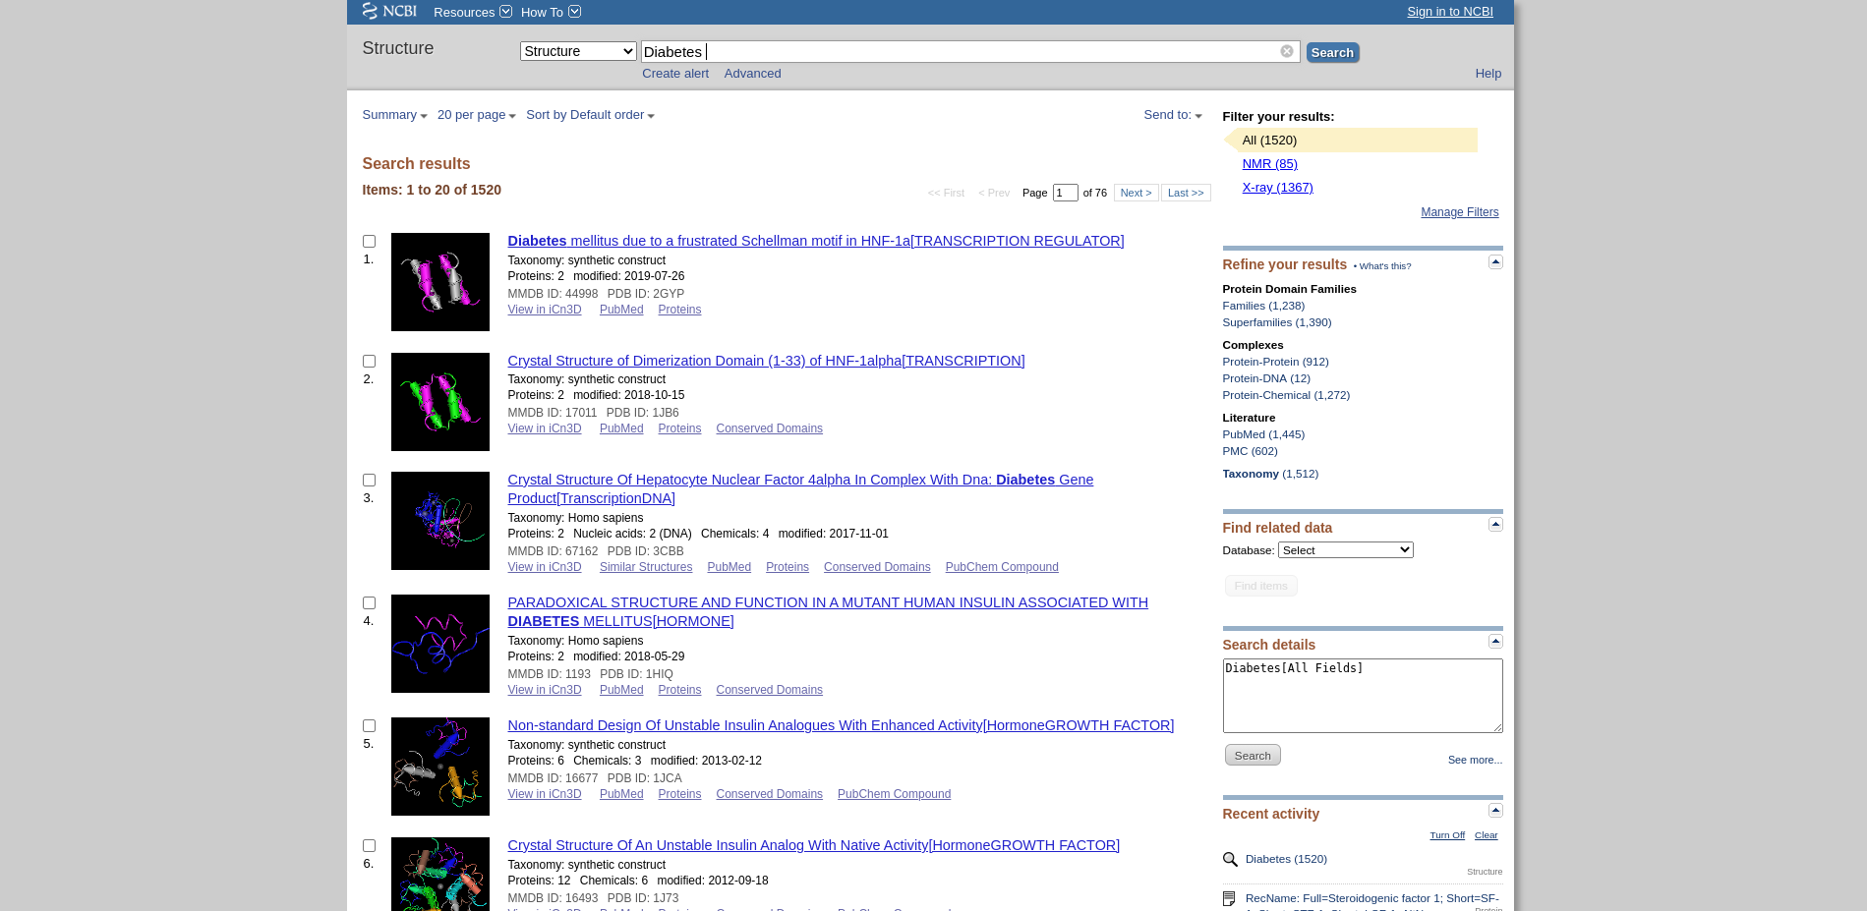
Fig23. Hit page for search query “Diabetes” in Structure resource
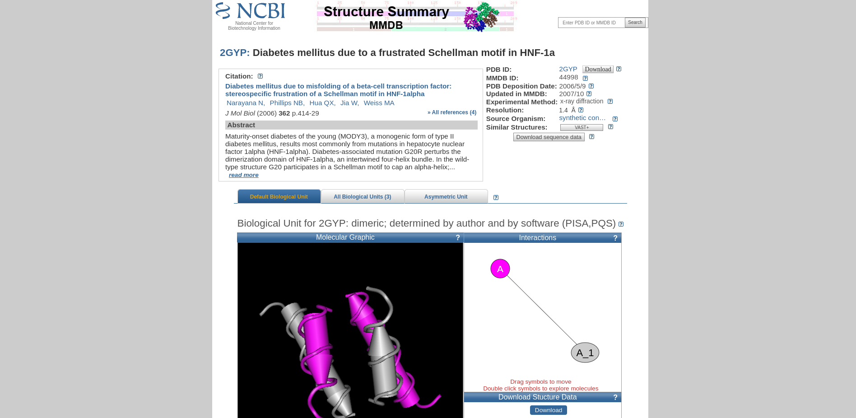
Fig24. Result Page for Structure resource on Diabetes [Diabetes mellitus due to a frustrated Schellman motif in HNF-1a]
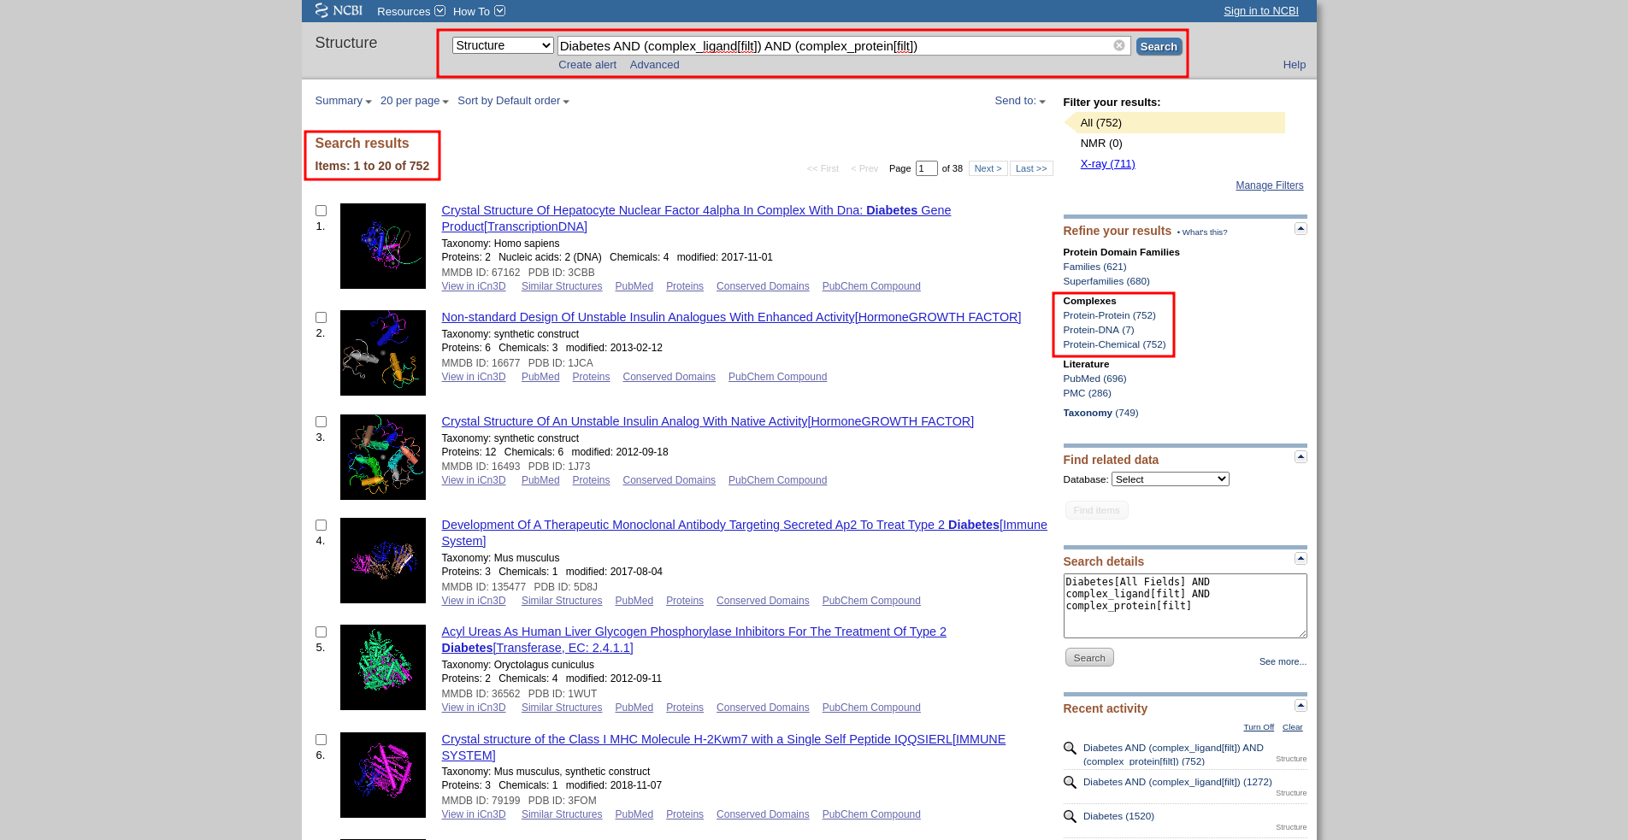
Fig25. Hit page for search query “Diabetes” in resource Structure with Limit option and refined results
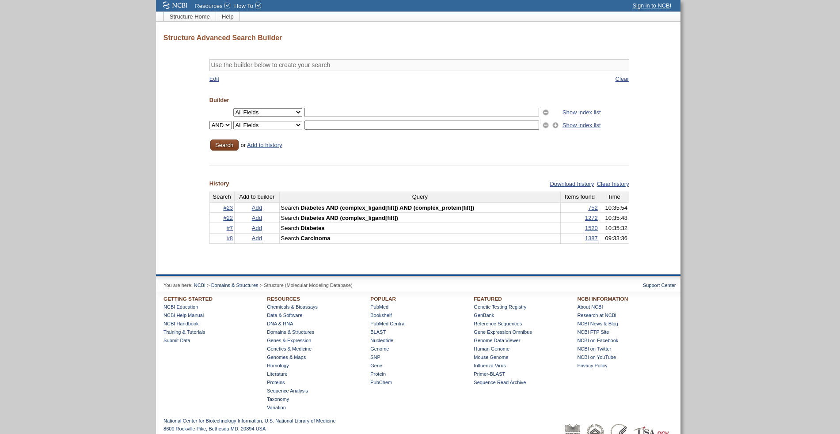
Fig26. Advanced search of Query “Diabetes” in Structure resource.
Resources:
The resources used were:
- Gene
- NLM Catalog
- Nucleotide
- Protein
- Structure

Conclusion:
To conclude the NCBI is a great website with plenty of resources to find and study data. The advanced filters, Limit options, The resource selection are all tools that are crucial to the efficient searching of information and NCBI makes it easy to access huge amounts of data swiftly and without bloat.

References:
- Gene
  - https://www.ncbi.nlm.nih.gov/gene/?term=Diabetes
  - https://www.ncbi.nlm.nih.gov/gene/advanced
  - https://www.ncbi.nlm.nih.gov/gene/16847
- NLM Catalog
  - https://www.ncbi.nlm.nih.gov/nlmcatalog/?term=Diabetes
  - https://www.ncbi.nlm.nih.gov/nlmcatalog/advanced
  - https://www.ncbi.nlm.nih.gov/nlmcatalog/466125
- Nucleotide
  - https://www.ncbi.nlm.nih.gov/nuccore/?term=Diabetes
  - https://www.ncbi.nlm.nih.gov/nuccore/advanced
  - https://www.ncbi.nlm.nih.gov/nuccore/NM_001122899.2
- Protein
  - https://www.ncbi.nlm.nih.gov/protein/?term=Diabetes
  - https://www.ncbi.nlm.nih.gov/protein/advanced
  - https://www.ncbi.nlm.nih.gov/protein/Q13285.2
- Structure
  - https://www.ncbi.nlm.nih.gov/structure/?term=Diabetes
  - https://www.ncbi.nlm.nih.gov/structure/advanced
  - https://www.ncbi.nlm.nih.gov/Structure/pdb/2GYP

